A Novena to the Sacred Heart
Google+ Print Mail Print HTML
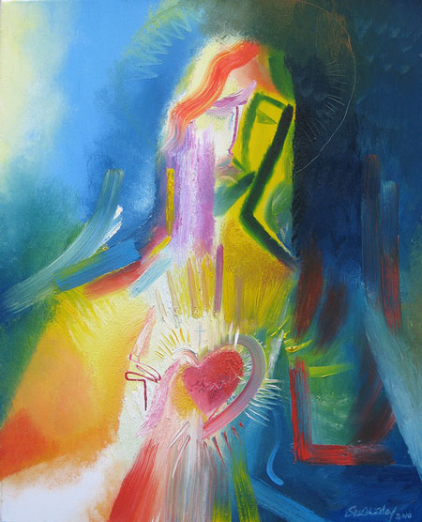

'Hearts on Fire' - The Solemnity of the most Sacred Heart of Jesus.
This novena is for the nine days leading to the Feast of the Sacred Heart, which falls this year on 12th June. You may pray the novena privately, in your family, in a parish group or with your neighbours or friends. If you are praying it with others, a different person may lead the novena each day, or you may share the various sections among those taking part.
Don't rush. Read the Scripture passage (on the image) and the meditation slowly, pausing when something strikes you. A short prayer follows, which takes up the theme of the day, and you end with the Novena Prayer.
Find out more about the modern devotion to the Sacred Heart of Jesus which was promoted by St Margaret Mary Alacoque with the help of the Jesuit priest St Claude de la Colombiere SJ >>
So, what does this feast mean to us today? We are made for love. How we all long to love and to be loved. Of course statues and pictures of the Sacred Heart will be very poor images of God’s love. What could show it? Fr Simon Bishop SJ reflects: "When I was a young boy, I remember going into my parents’ bedroom where, together, we would say night prayer. Above their bed was this lovely little statue of a rather fat-bellied man, with rosy cheeks and the biggest of smiles. His arms were held open wide and underneath were the words; “I love you this much!” Again, it was only a faint image of the love I received from my parents and an even fainter image of the love we receive from God, but it gave me an image. It was, of course, an image of the Cross."
Every time we celebrate the Eucharist we enter the greatest love story ever lived. At its heart we hear Jesus’ extraordinary words of love; “This is my Body given up for you … This is my Blood poured out for you.” This is no mere picture of love, this is love in action. The Lord gives Himself, pours out Himself, in love for us. How He longs to love us and to be loved by us. How He longs to fulfill our longings. How He longs for us to reveal His love to those searching for His love. So, let us allow the Lord to love us in the Holy Eucharist, at Mass; in adoration of the Blessed Sacrament, spending time with him, quietly, simply, every day, if possible, so that He, in turn, can fill those we meet with His love. Perhaps we don’t have rosy cheeks, perhaps we aren’t (too!) over-weight, but with a smile and with our hearts open wide, let all who meet us see the Lord saying to them: “I love you this much”!

Ninth Day: 12 June

The Welcoming Heart

Day9_TheWelcomingHeart_W500.jpg
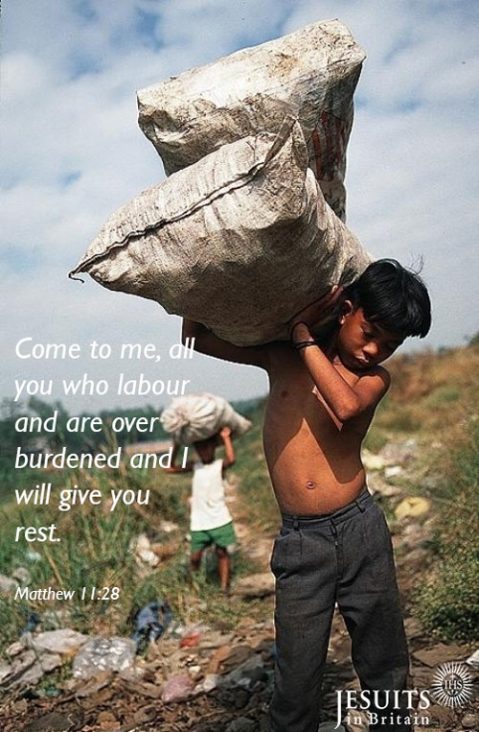

Reflection:
Come! We still welcome others with that little word: ‘Come right in, come in and take the weight off your feet!’ It was a word Jesus often used: ‘Come and see; come and eat.’ But how much more has Jesus to offer us? Rest, yes, but friendship unlike any other. Healing, guidance, peace, protection from evil, all offered by the Son of God who is ‘gentle and humble of heart’.

Prayer:
Be still and imagine the Lord calling your name and saying to you: ‘Come and give me your worries, come and trust me, come and listen to me as I speak my words in the gospel.’
End by thanking Jesus.

End with the Novena Prayer:
Lord Jesus Christ, your heart was moved with love for the men and women who came for help in their need. You healed the sick, you fed the hungry, you forgave sinners, you cried over Jerusalem. Above all, you showed to those who were prepared to listen the way to true life, for you are the Way the Truth and the Life.
Lord, your heart is still moved today by your people and their many needs. Open our hearts to hear your word, to accept your love, and to respond to your call. In particular, I beg you to grant me the favour I ask during this novena (make you request silently), provided that it will contribute to my own eternal good and to the building up of your Kingdom of justice, peace and love here on earth.
Most Sacred Heart of Jesus, I place all my trust in you.
Amen.

Eighth Day: 11 June

A Unifying Heart

Day8_AUnifyingHeart_650.jpg
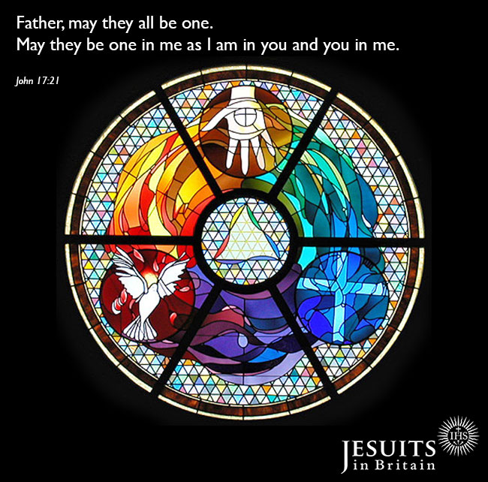

Reflection:
Rows in families, fallings out between friends, prejudice between groups, wars between nations are all signs of the absence of the Spirit. How much pain people endure today! The Spirit works to reconcile and build bridges but through the patience of others who seek to build up the community locally or nationally.

Prayer:
Lord, in our world of fragile relations where prejudice easily substitutes for knowledge, grant us the courage to welcome the outsider and to move beyond peer pressure. Help us to be ready to receive the Spirit at work.

End with the Novena Prayer:
Lord Jesus Christ, your heart was moved with love for the men and women who came for help in their need. You healed the sick, you fed the hungry, you forgave sinners, you cried over Jerusalem. Above all, you showed to those who were prepared to listen the way to true life, for you are the Way the Truth and the Life.
Lord, your heart is still moved today by your people and their many needs. Open our hearts to hear your word, to accept your love, and to respond to your call. In particular, I beg you to grant me the favour I ask during this novena (make you request silently), provided that it will contribute to my own eternal good and to the building up of your Kingdom of justice, peace and love here on earth.
Most Sacred Heart of Jesus, I place all my trust in you.
Amen.

Seventh Day: 10 June

A Merciful Heart

Day7_AMercifulHeart_W500.jpg
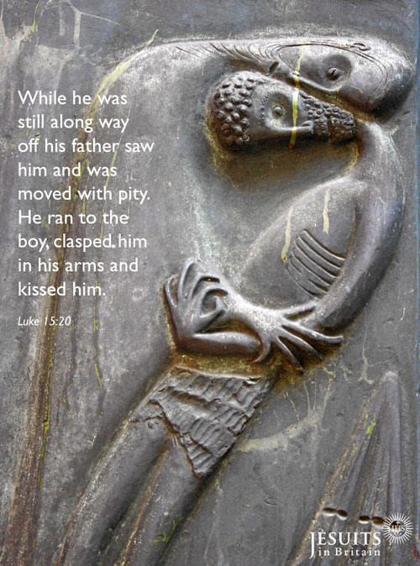

Reflection:
This story is more about the prodigal Father than the prodigal son! Jesus reveals what his father is like. Through our baptism we have been adopted into God's family with the privilege of calling God, Father. Which of us has not gone our own way or misused our gifts? Our heavenly Father is continually watching out for us, longing for our return, so he can clasp us in his arms.

Prayer:
Lord Jesus, may I never doubt your patience with me. I believe through the twists and turns of life you are drawing me home to my real self, my true home which is your Father's household. Give me the courage to experience the joy of receiving your forgiveness in the Sacrament of Reconciliation.

End with the Novena Prayer:
Lord Jesus Christ, your heart was moved with love for the men and women who came for help in their need. You healed the sick, you fed the hungry, you forgave sinners, you cried over Jerusalem. Above all, you showed to those who were prepared to listen the way to true life, for you are the Way the Truth and the Life.
Lord, your heart is still moved today by your people and their many needs. Open our hearts to hear your word, to accept your love, and to respond to your call. In particular, I beg you to grant me the favour I ask during this novena (make you request silently), provided that it will contribute to my own eternal good and to the building up of your Kingdom of justice, peace and love here on earth.
Most Sacred Heart of Jesus, I place all my trust in you.
Amen.

Sixth Day: 9 June

A Union of Hearts

Day6_UnionofHearts_W500.jpg
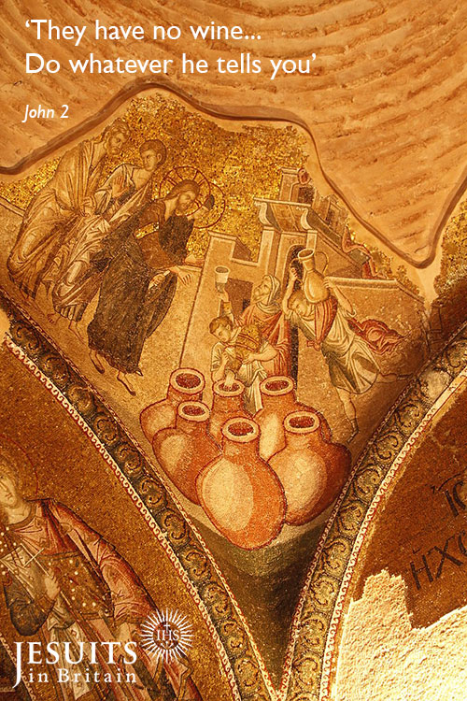

Reflection:
Mary with her feminine sensitivity knows that Jesus would not want their hosts to be embarrassed. She goes and tells the servants, 'Do whatever he tells you'. Whatever her Son does will be best; she trusts him unreservedly. She is not to be disappointed. What he does is beyond anything she could have dreamed of.

Prayer:
Mary, my mother, attune my heart to the heart of your Son. Open my heart to the needs of others. O Sacred Heart of Jesus, I place my trust in you.

End with the Novena Prayer:
Lord Jesus Christ, your heart was moved with love for the men and women who came for help in their need. You healed the sick, you fed the hungry, you forgave sinners, you cried over Jerusalem. Above all, you showed to those who were prepared to listen the way to true life, for you are the Way the Truth and the Life.
Lord, your heart is still moved today by your people and their many needs. Open our hearts to hear your word, to accept your love, and to respond to your call. In particular, I beg you to grant me the favour I ask during this novena (make you request silently), provided that it will contribute to my own eternal good and to the building up of your Kingdom of justice, peace and love here on earth.
Most Sacred Heart of Jesus, I place all my trust in you.
Amen.

Fifth Day: 8 June

A Peace-Giving Heart

Day5_APeacegivingheart_W900.jpg
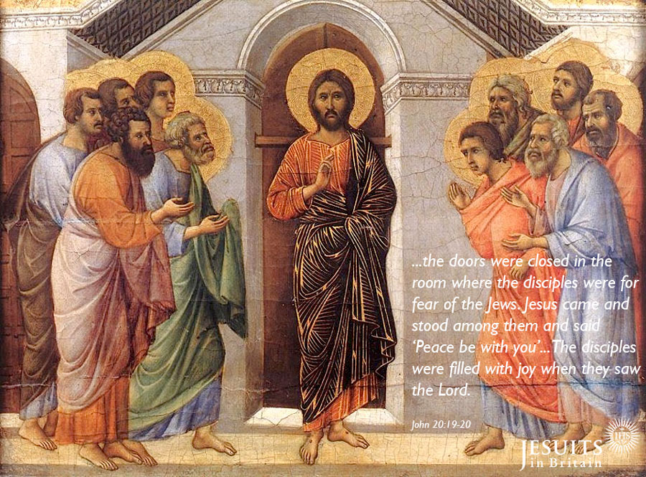

Reflection:
What relief and joy these words must have given to the eleven having deserted him during the Passion. Words that freed them from their guilt at having left him. Jesus gently restores them to his friendship. Now that Jesus has forgiven them, they too can forgive themselves and be forgiving to others. Admission of our own failings is the beginning of compassion.

Prayer:
Jesus, Prince of Peace, I do want to be at peace: peace with all that has been in my life, peace in my difficult relationships and peace with you. Jesus give me the courage to be a peace maker.

End with the Novena Prayer:
Lord Jesus Christ, your heart was moved with love for the men and women who came for help in their need. You healed the sick, you fed the hungry, you forgave sinners, you cried over Jerusalem. Above all, you showed to those who were prepared to listen the way to true life, for you are the Way the Truth and the Life.
Lord, your heart is still moved today by your people and their many needs. Open our hearts to hear your word, to accept your love, and to respond to your call. In particular, I beg you to grant me the favour I ask during this novena (make you request silently), provided that it will contribute to my own eternal good and to the building up of your Kingdom of justice, peace and love here on earth.
Most Sacred Heart of Jesus, I place all my trust in you.
Amen.

Fourth Day: 7 June

A Childlike Heart

Day4_AChildlikeheart_900.png
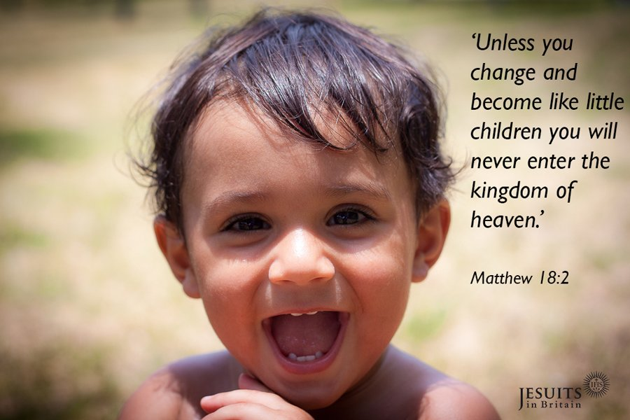

Reflection:
These words of Jesus may have fallen on deaf ears! Some did not understand that the dependency of children on their parents mirrored the dependency of us all on God. The Lord awaits our free response. There is no forcing, only a love that beckons and that never tires.

Prayer:
Lord, all I am and have is your gift. Help me learn from the spontaneity of children. Lord, grant me a childlike heart to allow you a free hand to create ever new possibilities for me even as I age.

End with the Novena Prayer:
Lord Jesus Christ, your heart was moved with love for the men and women who came for help in their need. You healed the sick, you fed the hungry, you forgave sinners, you cried over Jerusalem. Above all, you showed to those who were prepared to listen the way to true life, for you are the Way the Truth and the Life.
Lord, your heart is still moved today by your people and their many needs. Open our hearts to hear your word, to accept your love, and to respond to your call. In particular, I beg you to grant me the favour I ask during this novena (make you request silently), provided that it will contribute to my own eternal good and to the building up of your Kingdom of justice, peace and love here on earth.
Most Sacred Heart of Jesus, I place all my trust in you.
Amen.

Third Day: 6 June

A Docile Heart

Day3_ADocileHeart.png
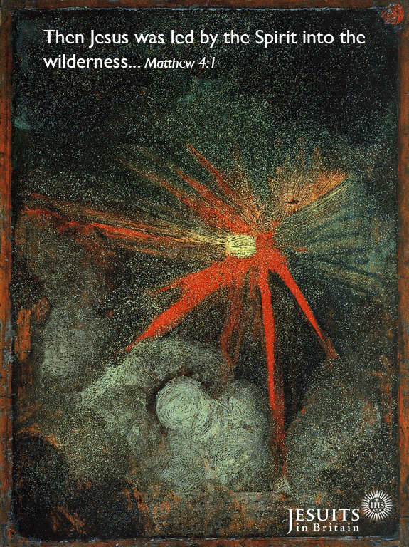

Reflection:
How inspiring that Jesus himself is docile to the Holy Spirit. He doesn't make decisions alone. No, he waits to be led, to be inspired by the Holy Spirit. That involved getting upbefore dawn and going off to lonely places to be alone with his Father so that silence in his heart could be in tune with the Holy Spirit. We too have received the Holy Spirit to guide our decisions. It is good to take time with the Lord and to ask for guidance to see whether the Spirit brings a sense of peace.

Prayer:
Lord, enlighten our minds to make good decisions, free from resistance, fear and self-preoccupation. May all we do give glory to God and be of service to others.

End with the Novena Prayer:
Lord Jesus Christ, your heart was moved with love for the men and women who came for help in their need. You healed the sick, you fed the hungry, you forgave sinners, you cried over Jerusalem. Above all, you showed to those who were prepared to listen the way to true life, for you are the Way the Truth and the Life.
Lord, your heart is still moved today by your people and their many needs. Open our hearts to hear your word, to accept your love, and to respond to your call. In particular, I beg you to grant me the favour I ask during this novena (make you request silently), provided that it will contribute to my own eternal good and to the building up of your Kingdom of justice, peace and love here on earth.
Most Sacred Heart of Jesus, I place all my trust in you.
Amen.

Second Day: 5 June

A Forgiving Heart

Day2_AForgivingHeart.png
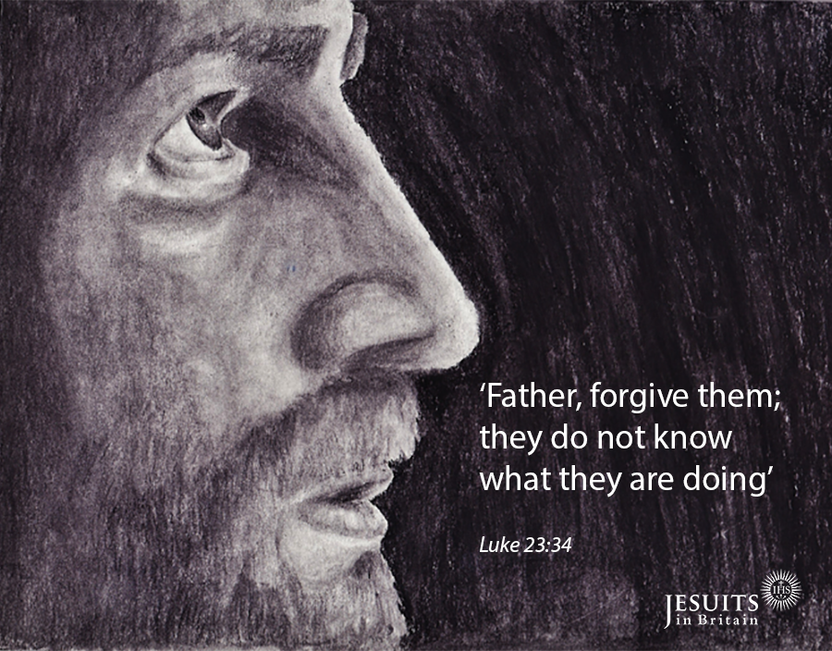

Reflection:
After all Jesus has been through: the hatred of the Jewish leaders, the weakness of Pilate, the fickleness of the crowd, the cruelty of the soldiers, he pleads with his Father to forgive them. This is surely 'the breadth and the length, the height and depth' of love. We can only sit or kneel in silence letting gratitude well up from within.

Prayer:
Lord Jesus, I am too small, too weak to grasp your love. I am overwhelmed by your love that transformed evil by goodness. A goodness strong enough to defeat the spiral of violence. Help us, Lord, weak as we are, to unite our efforts to yours, so that so much that is good and joyful in life is not lost.

End with the Novena Prayer:
Lord Jesus Christ, your heart was moved with love for the men and women who came for help in their need. You healed the sick, you fed the hungry, you forgave sinners, you cried over Jerusalem. Above all, you showed to those who were prepared to listen the way to true life, for you are the Way the Truth and the Life.
Lord, your heart is still moved today by your people and their many needs. Open our hearts to hear your word, to accept your love, and to respond to your call. In particular, I beg you to grant me the favour I ask during this novena (make you request silently), provided that it will contribute to my own eternal good and to the building up of your Kingdom of justice, peace and love here on earth.
Most Sacred Heart of Jesus, I place all my trust in you.

Amen.

First Day: 4 June

A Heart For Us

Day1_BodyandBlood.jpg
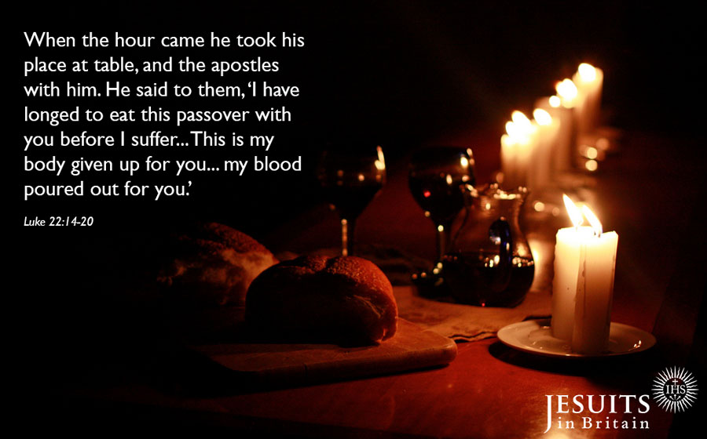

Reflection:
Jesus came on earth for us, lived, suffered and died for us; intercedes today with his Father for us. 'For us...and our salvation he came down from heaven... for our sake he was crucified...' (Creed) St Paul reminds us, 'If God is for us who can be against us?' Rom.8:31

Prayer:
Lord Jesus, I thank you that you gave your life for me. Help me to live for you and for others.

End with the Novena Prayer:
Lord Jesus Christ, your heart was moved with love for the men and women who came for help in their need. You healed the sick, you fed the hungry, you forgave sinners, you cried over Jerusalem. Above all, you showed to those who were prepared to listen the way to true life, for you are the Way the Truth and the Life.
Lord, your heart is still moved today by your people and their many needs. Open our hearts to hear your word, to accept your love, and to respond to your call. In particular, I beg you to grant me the favour I ask during this novena (make you request silently), provided that it will contribute to my own eternal good and to the building up of your Kingdom of justice, peace and love here on earth.
Most Sacred Heart of Jesus, I place all my trust in you.

Amen.
This Novena was written by Charlie Davy SJ for The Sacred Heart Messenger, an official publication of the Apostleship of prayer in Ireland. The introduction was given to us by Simon Bishop SJ.
Artist: Stephen B Whatley. Find out more on Stephen's website and flickr page.

